Title: Day 7 – IoT Smart Home Dashboard Network Topology

Date: 22 Sept 2025
Name: Nihar Ashraf

Introduction:
On Day 7, we focused on designing the network topology for the IoT Smart Home Dashboard. The main objective was to visualize how different system components (clients, devices, SQL database, and telemetry database) interact with each other. This step is crucial for demonstrating the system’s architecture in a clear and structured way.
Tasks Completed:
- Studied Network Topologies
- Reviewed star, bus, mesh, and hybrid topologies.
- Chose a star topology where all components communicate through a central node (IoT Dashboard).
- Defined System Interactions
- Clients (owners/users) interact with the IoT Dashboard.
- Dashboard controls gadgets (TV, AC, Fan, RoboVac).
- Dashboard stores:
  - Customer + Gadget information in SQL Database.
  - Telemetry logs in NoSQL DynamoDB.

- Created Topology Diagram
- Used PlantUML to generate the diagram.
- Saved .puml file and exported PNG for documentation and presentation.

Outputs:
- Topology Diagram in PlantUML
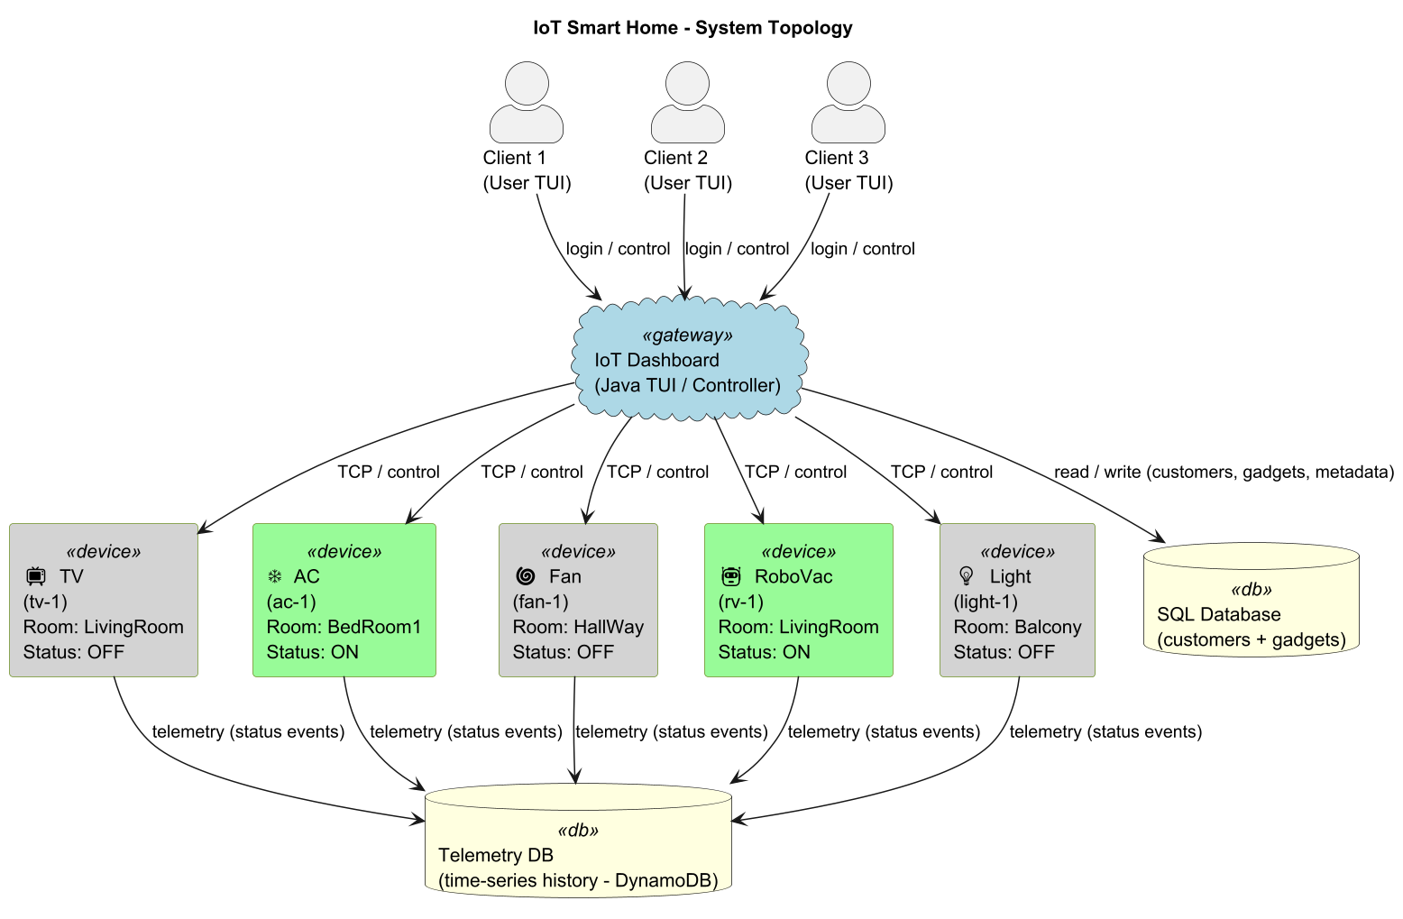
Learnings:
- Understood how to design network topologies for IoT projects.
- Learned the difference between UML vs. PlantUML (UML = modeling language, PlantUML = tool to draw UML diagrams).
- Identified that our system uses a Star Topology, with IoT Dashboard as the central hub.

Conclusion:
Day 7 successfully documented the network topology for the IoT Smart Home Dashboard. The diagram provides a clear view of how clients, devices, and databases interact through the Dashboard. This completes the architectural visualization needed for the project’s presentation and report.

